**Real time clock Using DS1307 RTC With Arduino UNO**

**Description:**

This Project is to design **Digital** **Clock** using DS1307 RTC With Ardunio Uno . This Digital clock can display We will be using a 16×2 LCD display the time and some other components. DS1307 is a low power serial real time clock with full binary coded decimal (BCD) clock/calendar plus 56 bytes of NV SRAM and The RTC provides year, month, date, hour, minute and second information.  In this we will set an alarm by giving the time in the code if the time is matches with the real time the led will on after changing time the led will off automatically.

### Materials Required:

* Arduino UNO(input)
* DS1307 RTC Module with Built-in cell.(input)
* 16×2 LCD Display(output)
* Jumper Wires
* Breadboard
* USB Cable to connect Arduino UNO with your Computer
* LED(output)

**Block Diagram:**

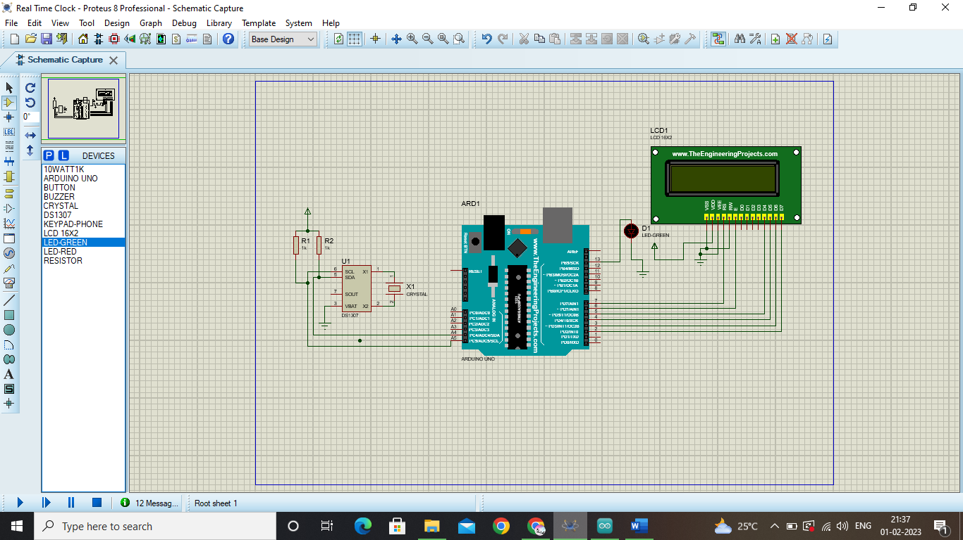

**Flow chart:**

Initialize the pins

Initialize RTC

Set RTCAlaram

yes

Blink led(led on)

If the time is over

Led off